Dangerous Plants Policy

xxxxx recognises that many plants can be harmful/poisonous when ingested and/or can cause allergic reactions. In accordance with safe guidelines, no Dangerous Plants (from the list below) will be allowed on the premises without an extensive risk assessment.

All outside areas have been checked for Dangerous Plants. In the rare case that a Dangerous Plant is found on the premises and we are unable to safely remove it, a risk assessment will be carried, taking into account:

- The age and maturity of the children
- If we can securely cordon off the Dangerous Plant/affected area
- What degree of supervision is needed
- How children may be affected
- What long term/permanent plan may be put in place

The Following list are the most commonly found Dangerous Plants that staff should be aware of as a possible hazard.

Name | Image | Harmful when:
Indoor Plants
Angels Trumpet  (Brugmansia or Datura) | 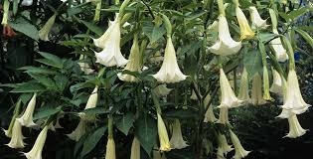 | Eaten
German Primula  (Primula Obconica) | 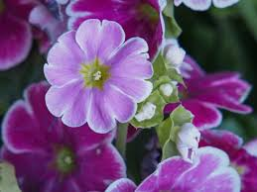 | Touched
Lantana  (Lantana) | 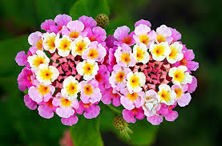 | Eaten/Touched
Leopard Lily  (Dieffenbachia) | 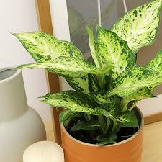 | Eaten/Touched
Oleander  (Nerium Oleander) | 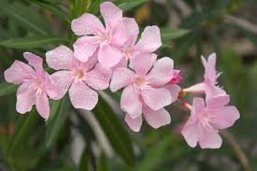 | Eaten
Rosy Periwinkle  (Catharantus Roseus) | 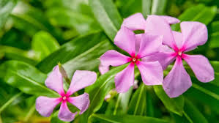 | Eaten
Umbrella Tree  (Schefflera) | 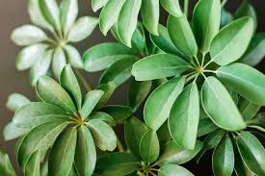 | Touched
Bulbs e.g. Daffodils & Hyacinths  (Narcissus)(Hyacinthus) |  | Eaten/Touched
Cut Flowers e.g. Daffodils, Monkshood , Mistletoe  (Narcissus) (Aconitum) (Viscum Album) | 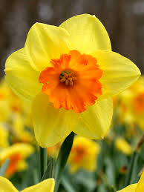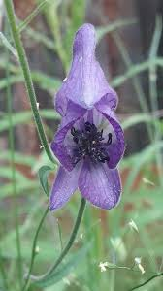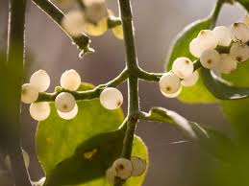 | Eaten/Touched
Garden Plants
Autumn Crocus  (Colchicum Autumnale) | 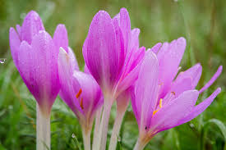 | Eaten
Castor Oil Plant  (Ricinus Communis) | 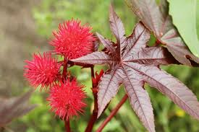 | Eaten/Touched
Foxglove  (Digitalis Purpurea) | 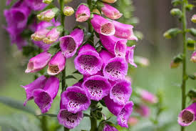 | Eaten
Freemontodendron  (Freemontodendron) | 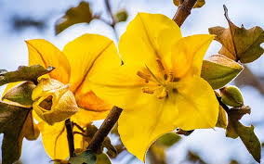 | Touched
Ivy  (Hedera Helix) | 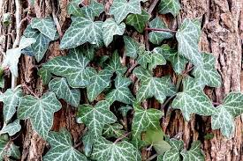 | Eaten/Touched
Laburnum  (Laburnum Anagyroides) | 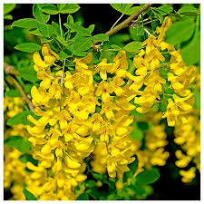 | Eaten
Leyland Cypress  (X Cupressocyparis) | 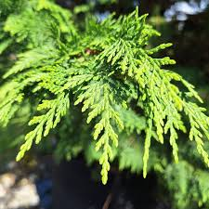 | Touched
Lily-of-the-Valley  (Convallaria Majalis) | 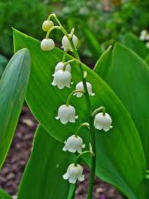 | Eaten
Lupins  (Lupinus) | 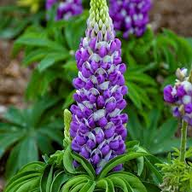 | Eaten
Mezereon  (Daphne Mezereum) | 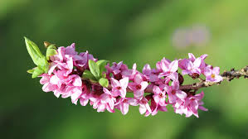 | Eaten/Touched
Monkshood  (Aconitum Napellus) | 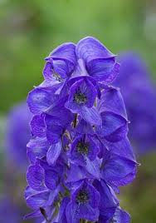 | Eaten/Touched
Pokeweed  (Phytolacca) | 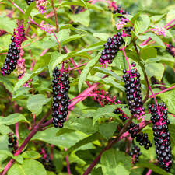 | Eaten/Touched
Rue  (Ruta Graveolens) | 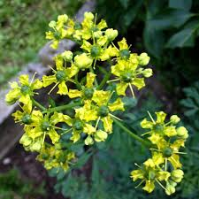 | Touched
Spurge  (Euphorbia) | 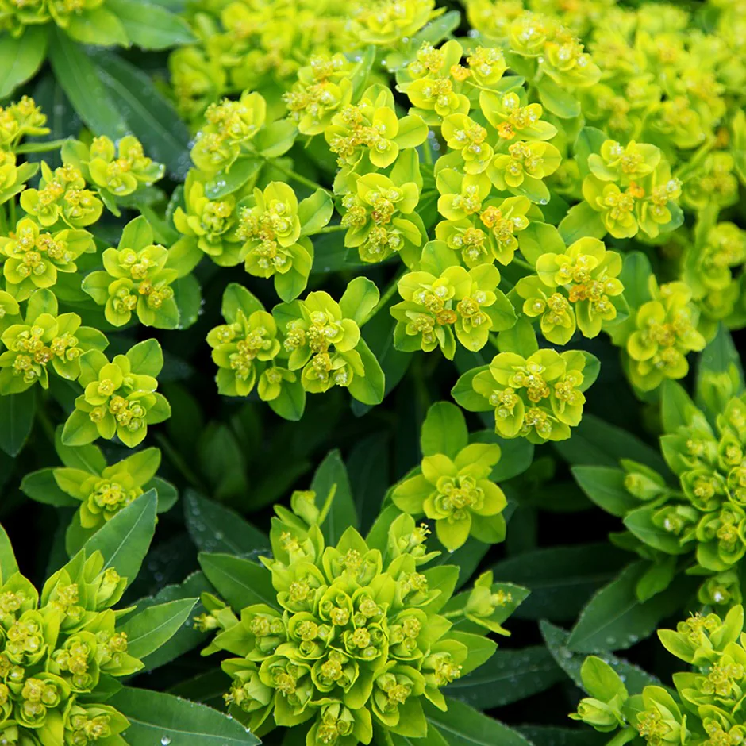 | Eaten/Touched
Yew  (Taxus Baccata) | 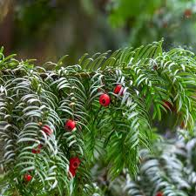 | Eaten
Wild and Native Plants
Black Bryony  (Tamus Communis) | 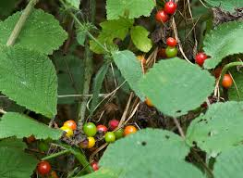 | Eaten
Black Nightshade  (Solamum Nigrum) | 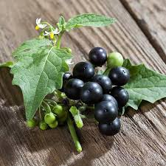 | Eaten
Cherry Laurel  (Prunus Laurocerasus) | 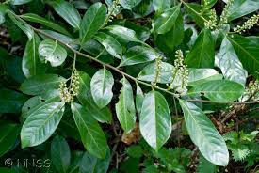 | Eaten
Deadly Nightshade  (Atropa Belladonna) | 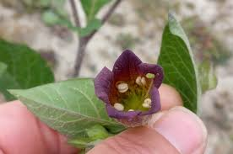 | Eaten
Giant Hogweed  (Heracleum Mantegazzianum) | 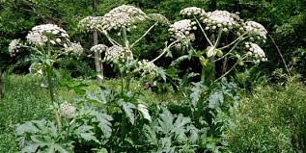 | Touched
Hemlock  (Conium Maculatum) | 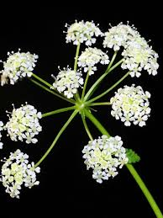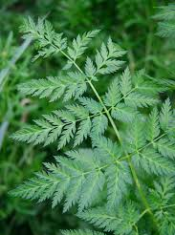 | Eaten
Hemlock Water Dropwort  (Oenanthe Crocata) | 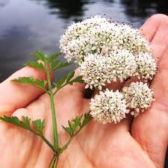 | Eaten
Horse Chestnut  (Aesculus Hippocastanum) | 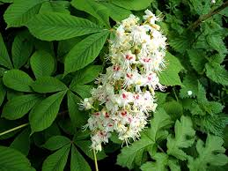 | Eaten
Lords-and-Ladies  (Arum Maculatum) | 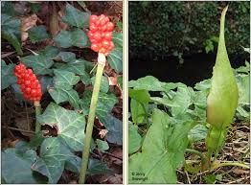 | Eaten
Mistletoe  (Viscum Album) | 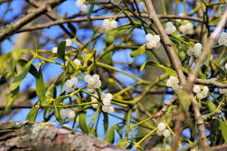 | Eaten
Snowberry  (Symphoricarpos Albus) | 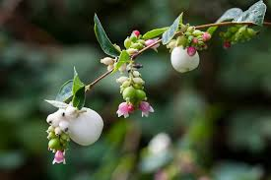 | Eaten
Wild Privet  (Ligustrum Vulgare) | 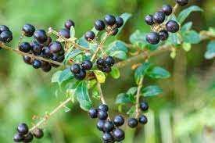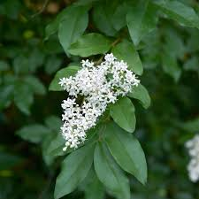 | Eaten
Woody Nightshade  (Solanum Dulcamara) | 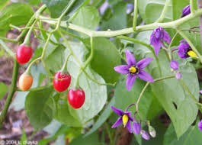 | Eaten

In an emergency case of potential poisoning, 999 will be called immediately.

This policy was adopted by: | xxxxx | Date: | xxxxx
To be reviewed by: | xxxxx | Signed: | xxxxx

