Process of how to book:

We ensured that our website was clear on the process of how to book to allow parents to have a smooth and easy way of accessing the services with no stress or complications.
When you go to book online through our website, it will give you the option of what service you would like to book and which school.
Page 1:
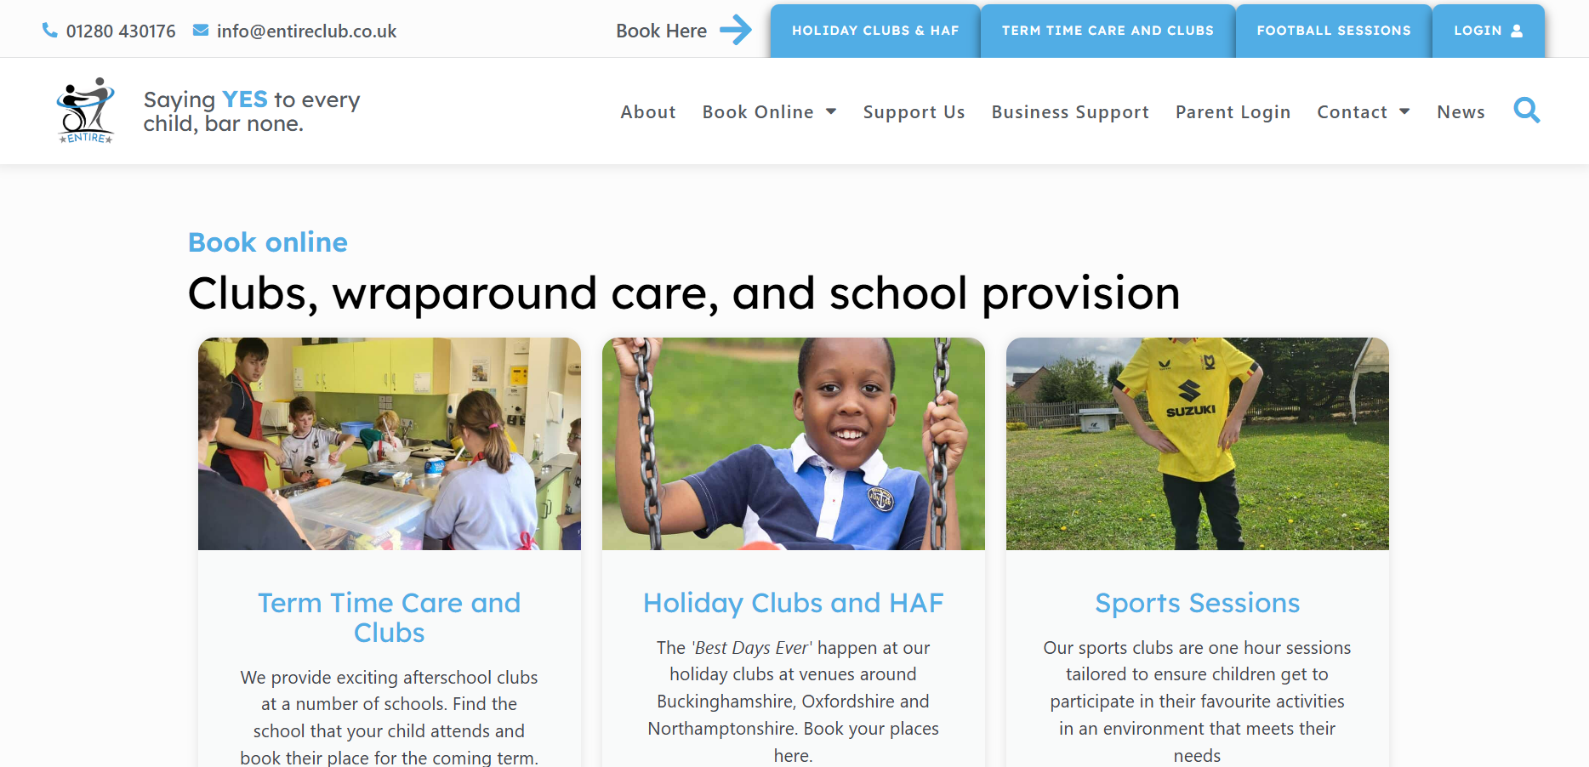

Page 2:
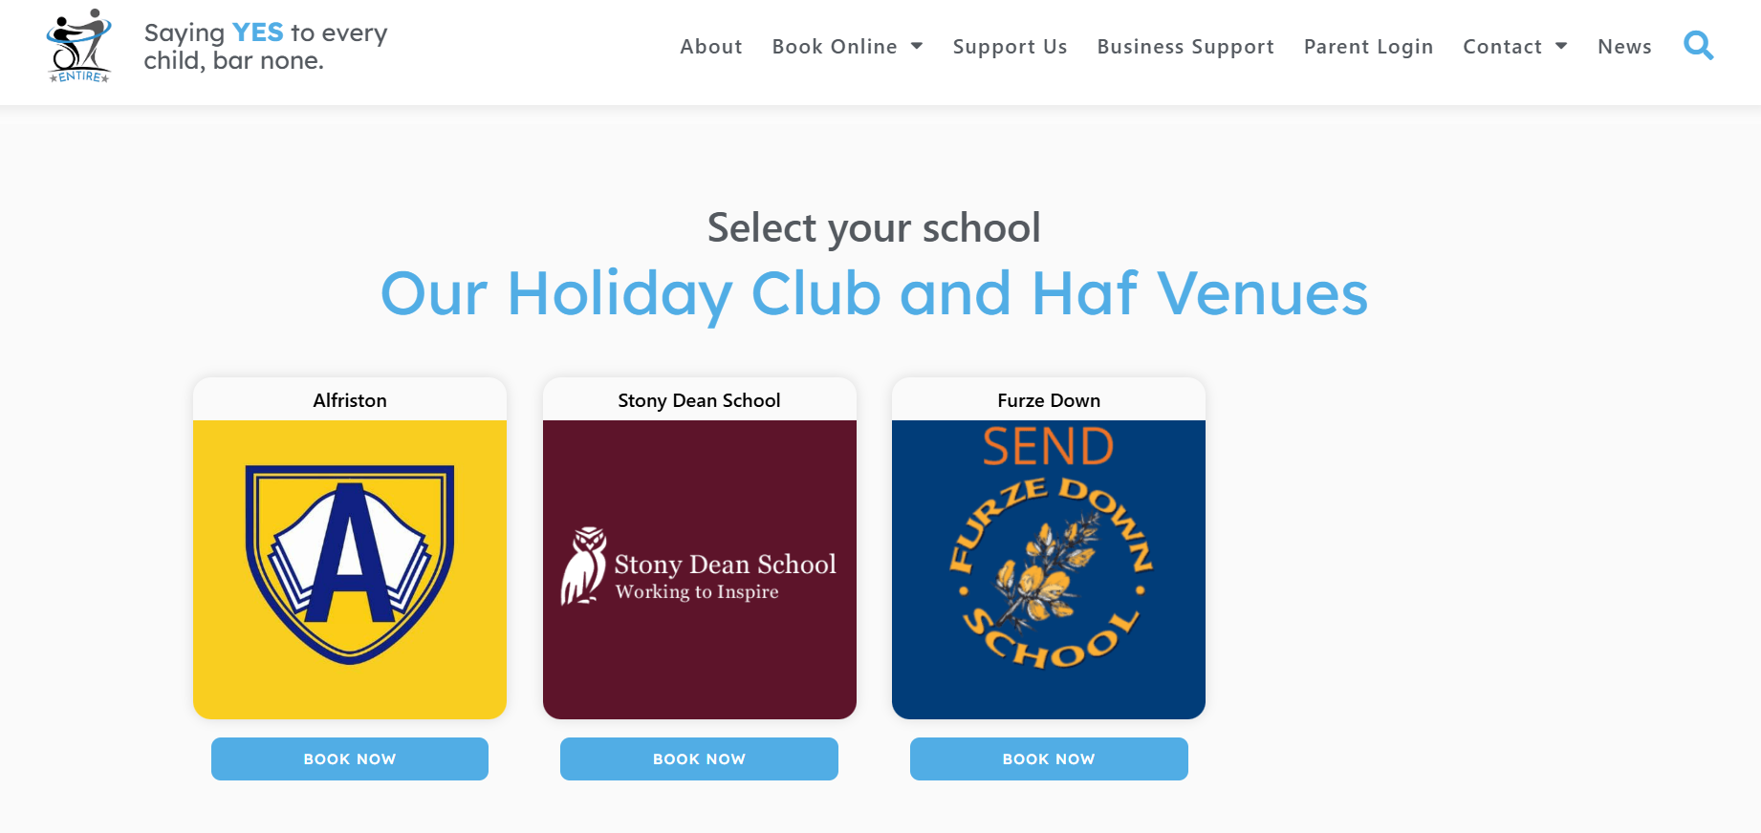
Page 3:
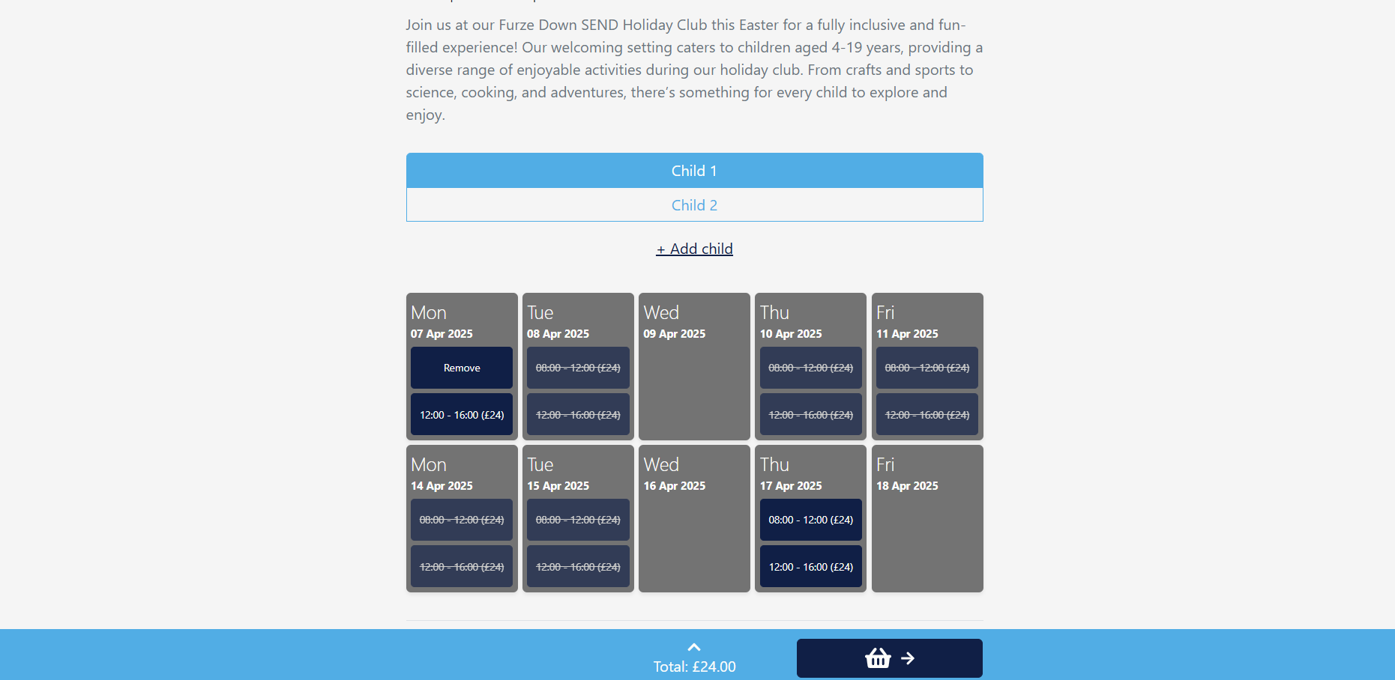

- Once you have selected the wanted club/ provision and the school you are wanting to attend, it will then take you to a page that shows the available slots remaining.
- It will then ask for an email address so it can link to your parent portal.
- From this you will be able to choose a preferred payment method, which you will then receive an email including the dates you have booked, the times, payment option and the amount due.

When choosing the payment option you will have the option of:

- Credit card by phone
- Child care vouchers
- Pupil premium
- Chat

