Sensory stories:

Entire provide a sensory story to parents before each camp to help prepare children for the experience. This carefully designed story includes:
- An address.
- What to look for upon arrival.
- Photos and visuals
- Descriptive language to outline what children can expect.
It is particularly beneficial for children and/or parents who may experience anxiety, sensory sensitivities, or require additional support in transitions. By familiarising children with the camp environment in advance, we aim to create a smooth and positive experience, ensuring they feel comfortable, prepared, and excited for their time with us.
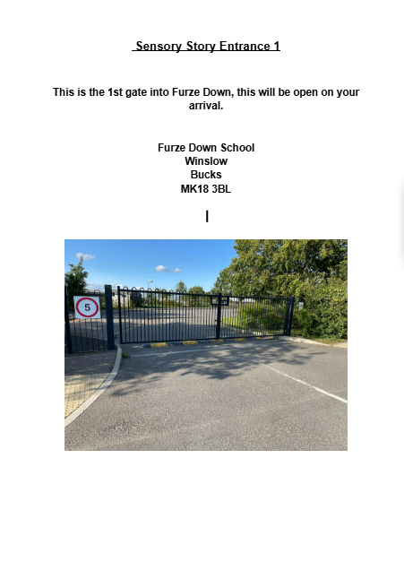
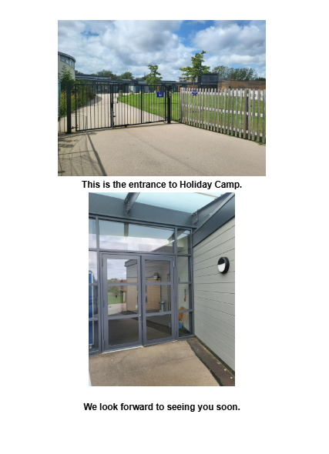
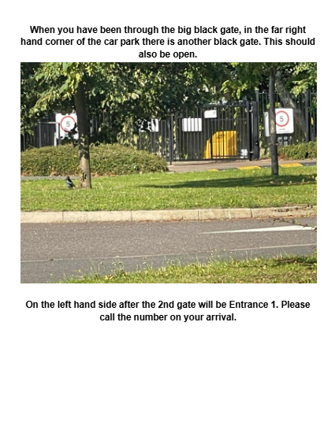
We ensure that there is a completed sensory story for every camp and every entrance for our provisions at Entire. This gets sent out to new parents after a booking and OPP call is made to ease any worries for new starters.

